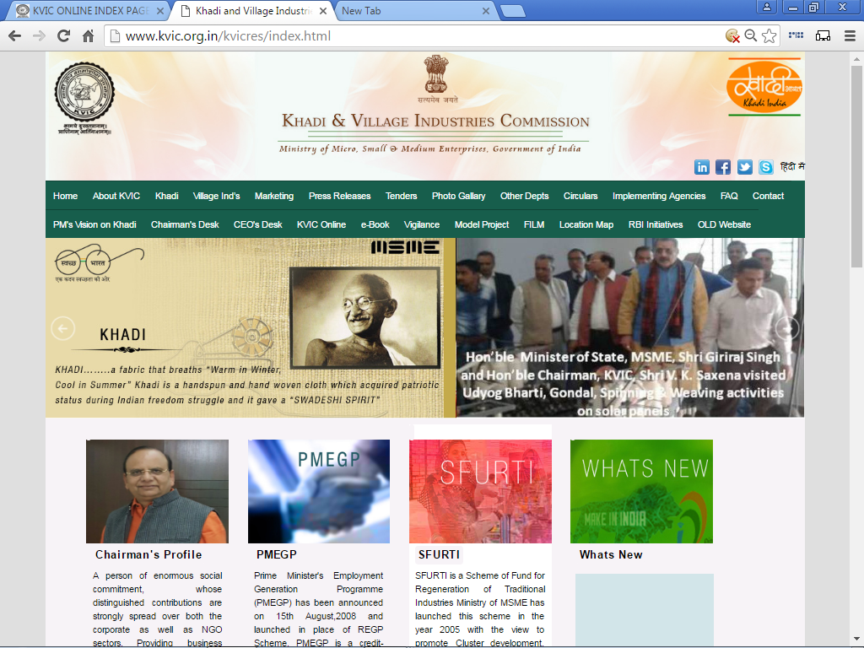

“USER MANUAL”
for
PMEGP e-PORTAL
for
IMPLEMENTING AGENCY
Under
PMEGP SCHEME
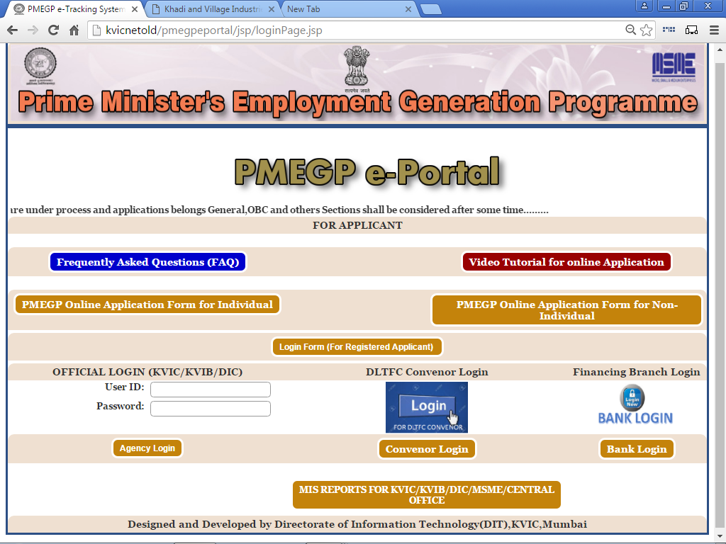
STEP No:- 1 (A)
Please visit Khadi & Village Industries Commission Official Website i.e. www.kvic.org.in and Click on “KVIC Online” Button as shown below:-

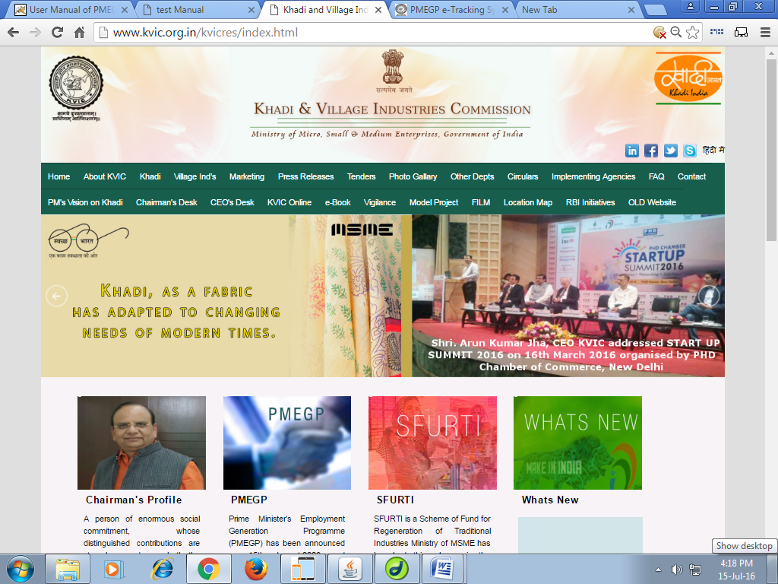
Click here

STEP No:- 1 (B)

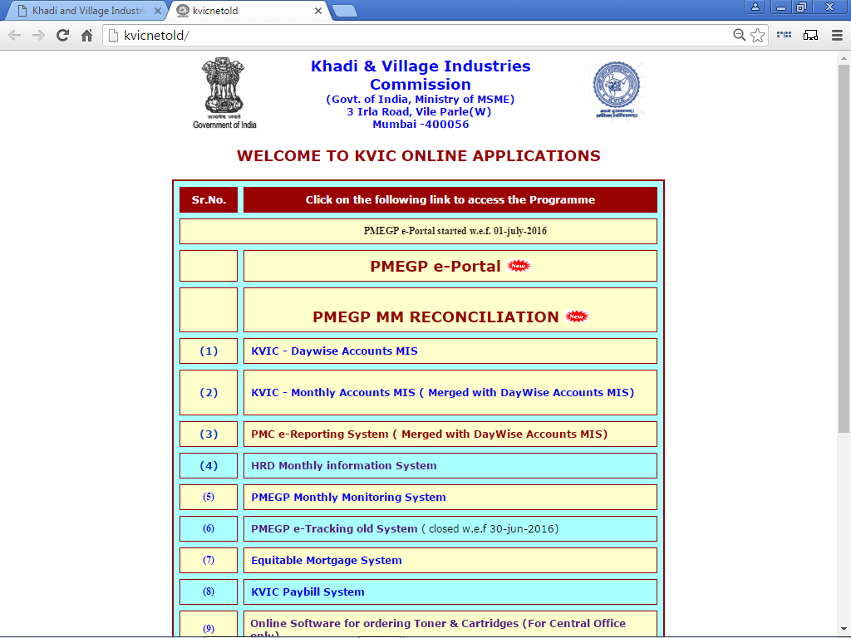
After Entering into next webpage, please click on “PMEGP e-Portal” Link as shown below:-
Click here
STEP No:- 2 (A)

After Entering PMEGP e-Portal, Please Enter Your User ID and Your Password then Click On “Agency Login Button” Link as shown below:-

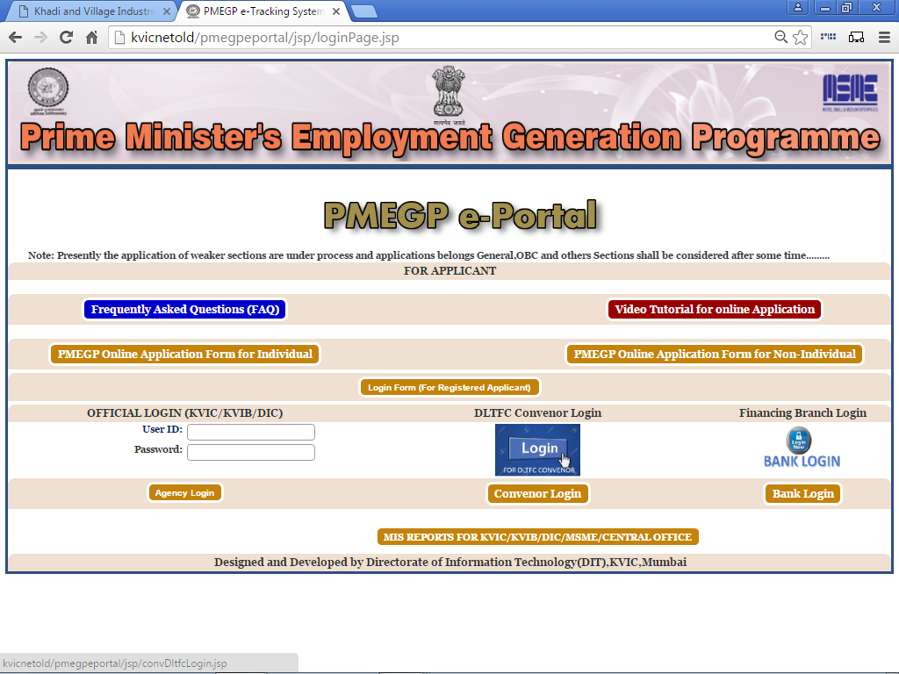
Agency Login

After Login, Home Page as shown below:-
STEP No:- 3 (A)

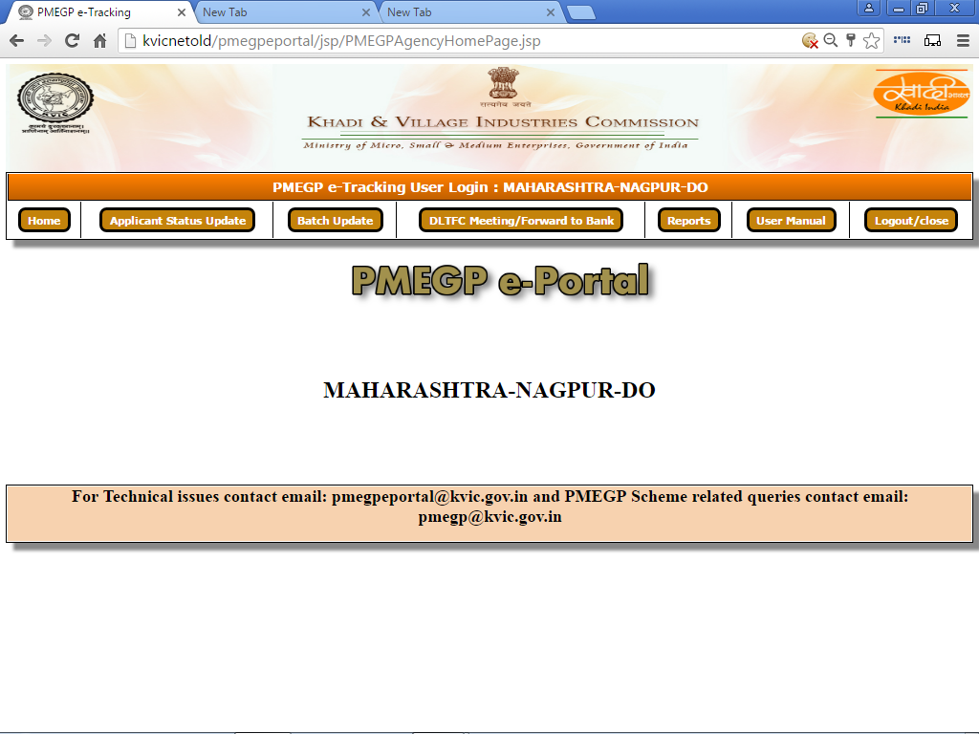
Home – To Return the Home Page
Applicant Status Update – Update current status under Progress/Rejected by Agency / Forwarded to DLTFC
DLTFC Meeting/Forward To Bank – Meeting Detail and Forward to Bank
Report – To View Full Report
User Manual – To download the User Manual in PDF format
Logout/close – To close the Program and return to log-in Page

STEP No:- 3 (B)i

After Entering 'Application Status Update' Page as shown below:-

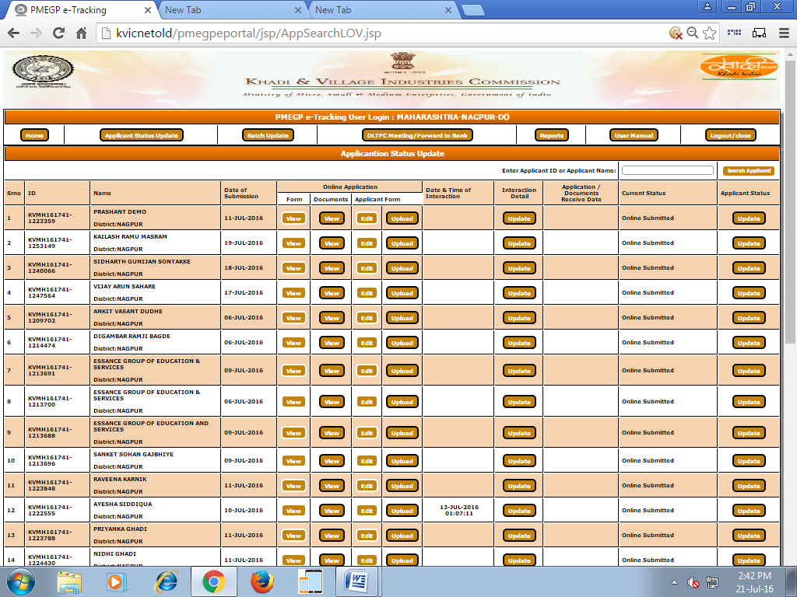

STEP No:- 3 (B)ii

You can Search By 'Applicant ID' or 'Applicant Name', Page as shown below:-



Enter
ID or Name

STEP No:- 3 (B)iii

After Click on 'View' PDF as shown below:-
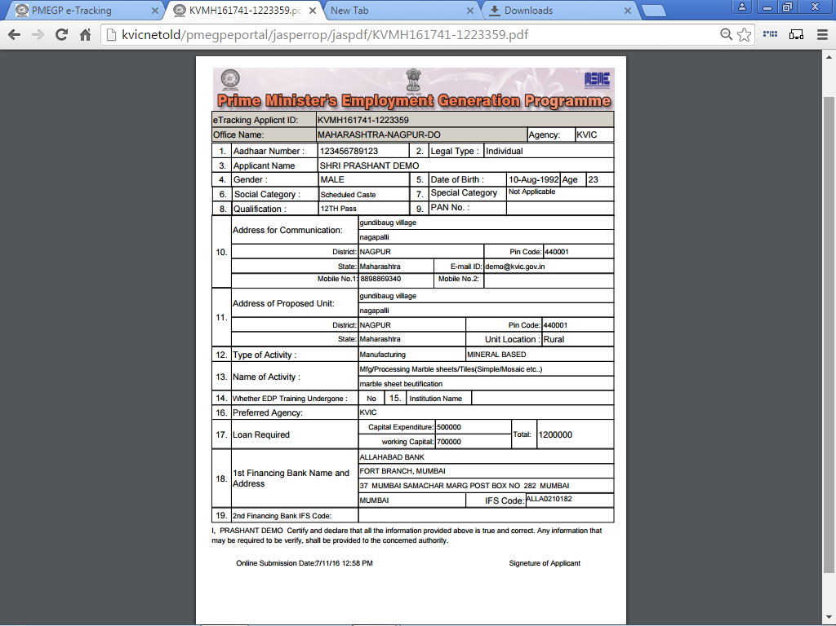

STEP No:- 3 (B)iv

After Click on 'Edit', You can Edit Your Form, Page as shown below:-
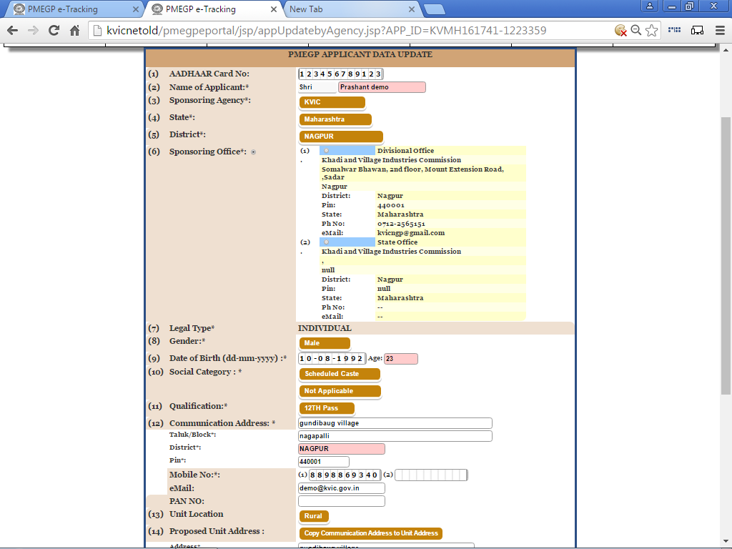

STEP No:- 4 (A)

Send
Email
To View
or Print
To View PDF or Download
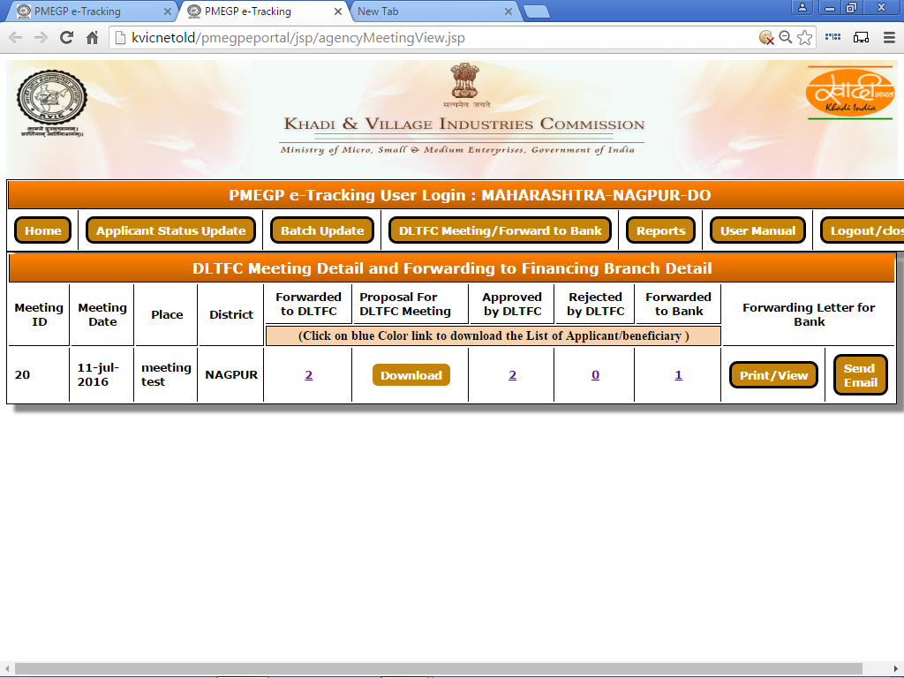
After Entering 'DLTFC Meeting/Forward To Bank' Page as shown below:-

